Department of Computer Science (BS(E)-I-A)

Alarm Clock project

Group Leader: Sehrish Majeed
Roll No. 24014119-141

Group Members:

1.Saba Ghazanfar_ Roll No. 24014119-129
2.Noor Fatima_ Roll No. 24014119-282

Course: OOP(CS-103)

Instructor’s Name: Mr. Naveed Abbas
Submission Date.
1st May,2025

Alarm Clock Project Documentation in C++

Table of Contents
1. Introduction
2. Step-by-Step Development
- Step 1: Write Code
- Step 2: Compile Code
- Step 3: Run Program
- Step 4: Output
3. Conclusion

1. Introduction
This project is a simple Alarm Clock application written in C++. The program allows the user to set a time, and it checks the system clock to ring the alarm at the correct moment.

2. Step-by-Step Development

Step 1: Writing the Code
I wrote the following code in a file named alarm.cpp:
#include <iostream>
#include <ctime>
#include <thread>
#include <chrono>
#include <iomanip>

using namespace std;

int main() {
int alarmHour, alarmMinute;
char colon;

cout << "Set alarm time (HH:MM): ";
cin >> alarmHour >> colon >> alarmMinute;

cout << "Alarm is set for " << setfill('0') << setw(2) << alarmHour << ":"
<< setfill('0') << setw(2) << alarmMinute << ".\n";
cout << "Waiting for alarm...\n";

while (true) {
time_t now = time(0);
tm* currentTime = localtime(&now);

cout << "Current time: "
<< setfill('0') << setw(2) << currentTime->tm_hour << ":"
<< setfill('0') << setw(2) << currentTime->tm_min << ":"
<< setfill('0') << setw(2) << currentTime->tm_sec << "\r";
cout.flush();

if (currentTime->tm_hour == alarmHour && currentTime->tm_min == alarmMinute) {
cout << "\nWAKE UP! WAKE UP! ALARM RINGING!\n";
break;
}

this_thread::sleep_for(chrono::seconds(1));
}

return 0;
}
Screenshot:
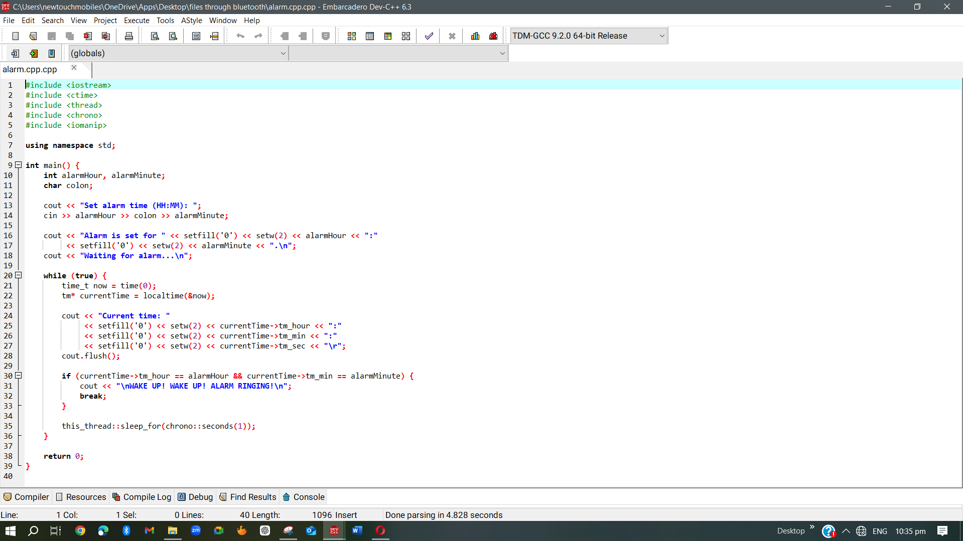

Step 2: Compiling the Code
To compile the program, I used to Function 9 key such as below Screenshot.
Screenshot:
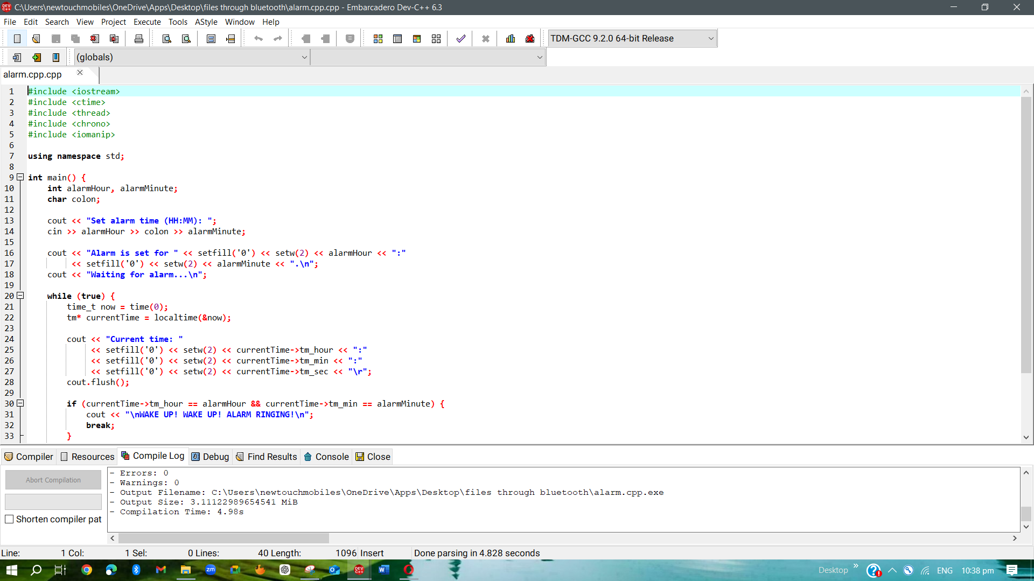

Step 3: Running the Program
I executed the compiled alarm.exe file and set the alarm time via console input.
Screenshot:
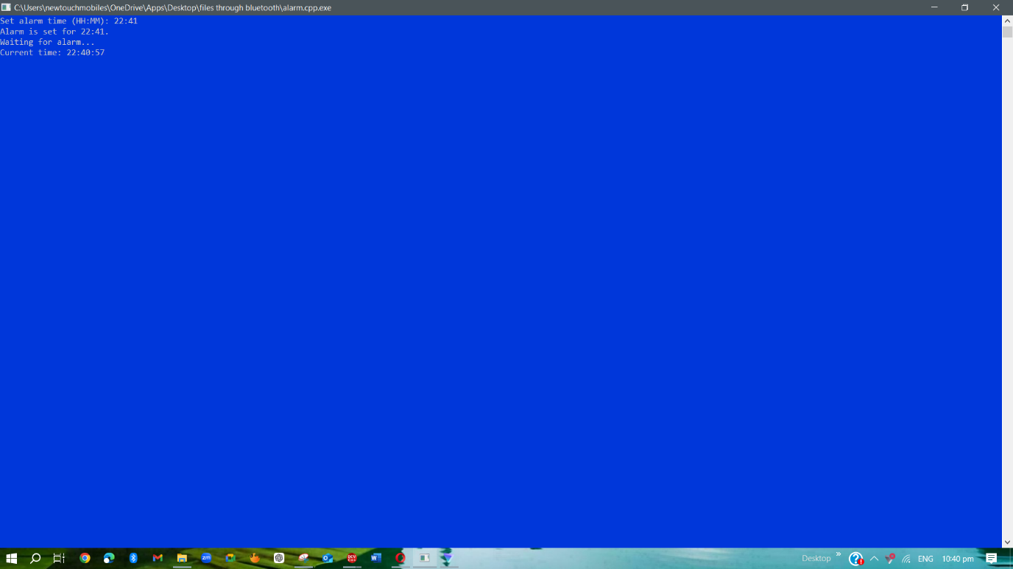

Step 4: Alarm Output
Once the system time matched the alarm time, the program displayed an alarm message.
Screenshot:
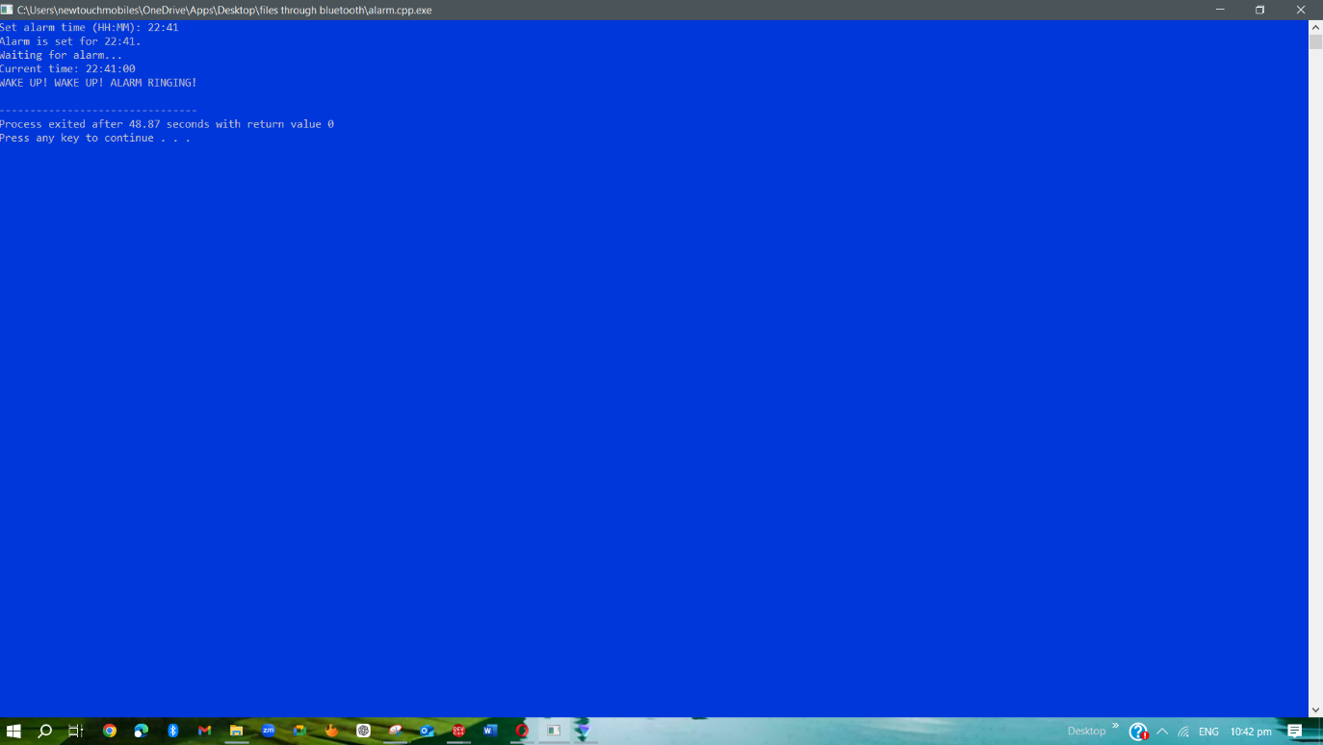

3. Conclusion
In this project, I created a basic Alarm Clock using C++. The program takes user input for time, checks the current system time continuously, and displays a message when the time matches. This helped me understand how to use loops, system time functions, and conditional logic in C++.

